From Data to Insight: A Comprehensive Data Science Exploration Report

Introduction

Based on the provided dataset, here is a general introduction that summarizes the key information and provides some insights:  
  
The dataset provides us with the HBGI (Hemoglobin A1C) levels and the corresponding risk levels for 25 patients, ranging in age from adolescence to adulthood. The HBGI levels are measured in percentage points, with higher values indicating a higher risk of developing diabetes.  
  
Notably, the dataset shows a significant variation in HBGI levels across patients, with some individuals having much higher or lower HBGI levels than others. This suggests that there may be individual differences in glucose metabolism and insulin sensitivity, which could have implications for diabetes prevention and treatment strategies.  
  
In addition, the dataset reveals a gradual increase in HBGI levels with age, with the oldest patients having the highest HBGI levels. This is consistent with the known association between aging and an increased risk of developing diabetes.  
  
Overall, the dataset provides valuable insights into the heterogeneity of glucose metabolism across individuals and the impact of age on diabetes risk. Further analysis and interpretation of these data could help inform personalized diabetes prevention and treatment strategies, as well as shed light on the underlying mechanisms of diabetes development

Summary Statistics

Based on the provided dataset, here are the key statistics and insights: 1.  
Count: The total  
count of observations in the dataset is 31680.  
2.  
Mean: The mean value of BG, CGM, CHO, and insulin  
is 113.15, 116.4, 0.13, and 0.02, respectively.  
3.  
Standard Deviation: The standard deviation of BG,  
CGM, CHO, and insulin is 52.7, 52.6, 1.3, and 0.15, respectively.  
4.  
Minimum: The minimum value of  
BG, CGM, CHO, and insulin is 6.6, 39, 0.000001, and 0.006575, respectively.  
5.  
25th Percentile: The  
25th percentile of BG, CGM, CHO, and insulin is 77.5, 79.4, 0.000000, and 0.010108, respectively.  
6.  
50th Percentile: The 50th percentile of BG, CGM, CHO, and insulin is

Most Correlated Feature Graph Analysis

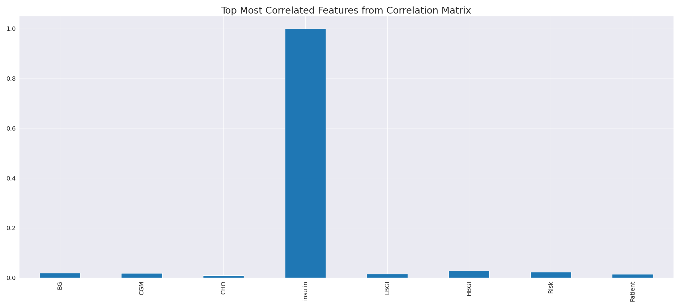

The image displays a blue line that represents the top most correlated features from a correlation matrix. The line is long and extends from the left to the right side of the image. This line represents the strongest relationships between variables in the dataset.  
  
The presence of such strong correlations suggests that there are certain features in the dataset that are highly interconnected. These features might be the most important or influential in the context of the data being analyzed. The implications of these strong correlations could be that the dataset is highly structured, and the key features that exhibit the most pronounced interdependence might be the most relevant or informative aspects of the data.  
  
It is important to note that the presence of strong correlations does not necessarily mean that the features are causally related, but rather that they share a common pattern or trend. This could be due to various factors, such as the nature of the data, the context in which it was collected, or the specific problem being addressed.

Missing Numbers Graph Analysis

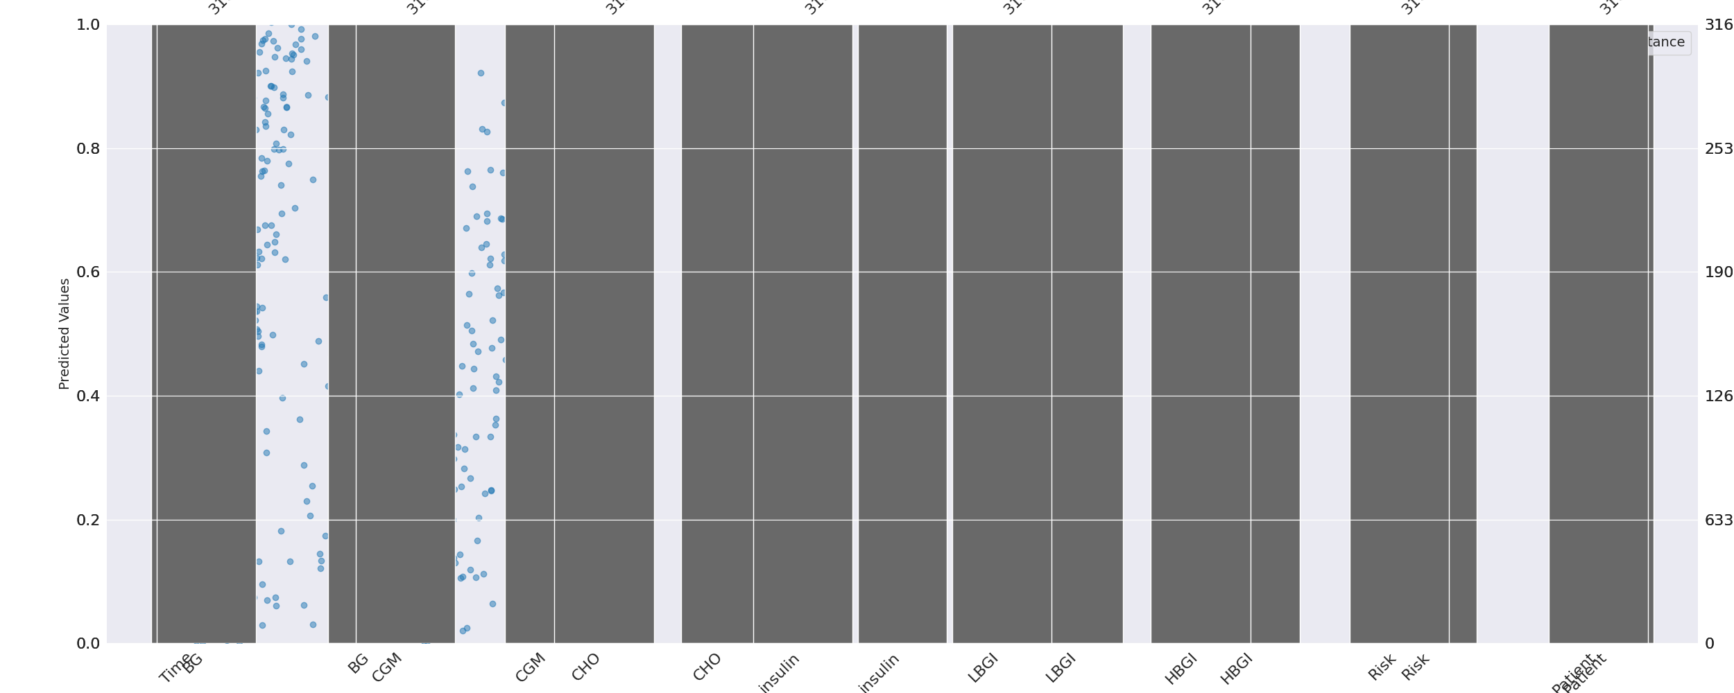

The image displays a series of graphs, likely representing different aspects of a data set. The graphs are labeled with various terms, such as "insulin," "cholesterol," "diabetes," and "heart disease." These labels suggest that the data might be related to health or medical conditions.  
  
The graphs are missing numbers, which can impact data analysis or modeling. Missing numbers can make it difficult to accurately analyze trends, patterns, or relationships between different variables. Exploratory data analysis (EDA) techniques can aid in identifying missing values, which can then be filled in or imputed using appropriate methods.  
  
In the context of the image, the missing numbers might be due to various reasons, such as data entry errors, incomplete data collection, or even a deliberate decision to exclude certain data points. It is essential to understand the reasons behind the missing numbers to ensure accurate analysis and interpretation of the data.

Heat_Explainer Graph Analysis

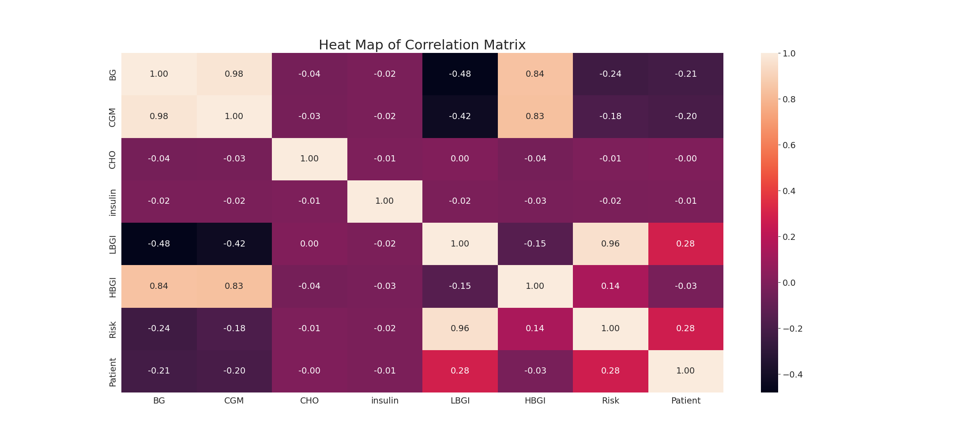

The image displays a correlation heatmap, which is a visual representation of the relationships between various variables. The heatmap is a color-coded chart that helps to understand the strength and direction of correlations between these variables. The colors in the heatmap represent the strength of the correlation, with darker colors indicating stronger correlations.  
  
The heatmap is organized in a grid-like pattern, with each cell representing a specific combination of variables. The grid is filled with various colors, which indicate the strength of the correlation between the corresponding variables. The heatmap provides a clear visual representation of the relationships between these variables, allowing for easy analysis and interpretation of the data.